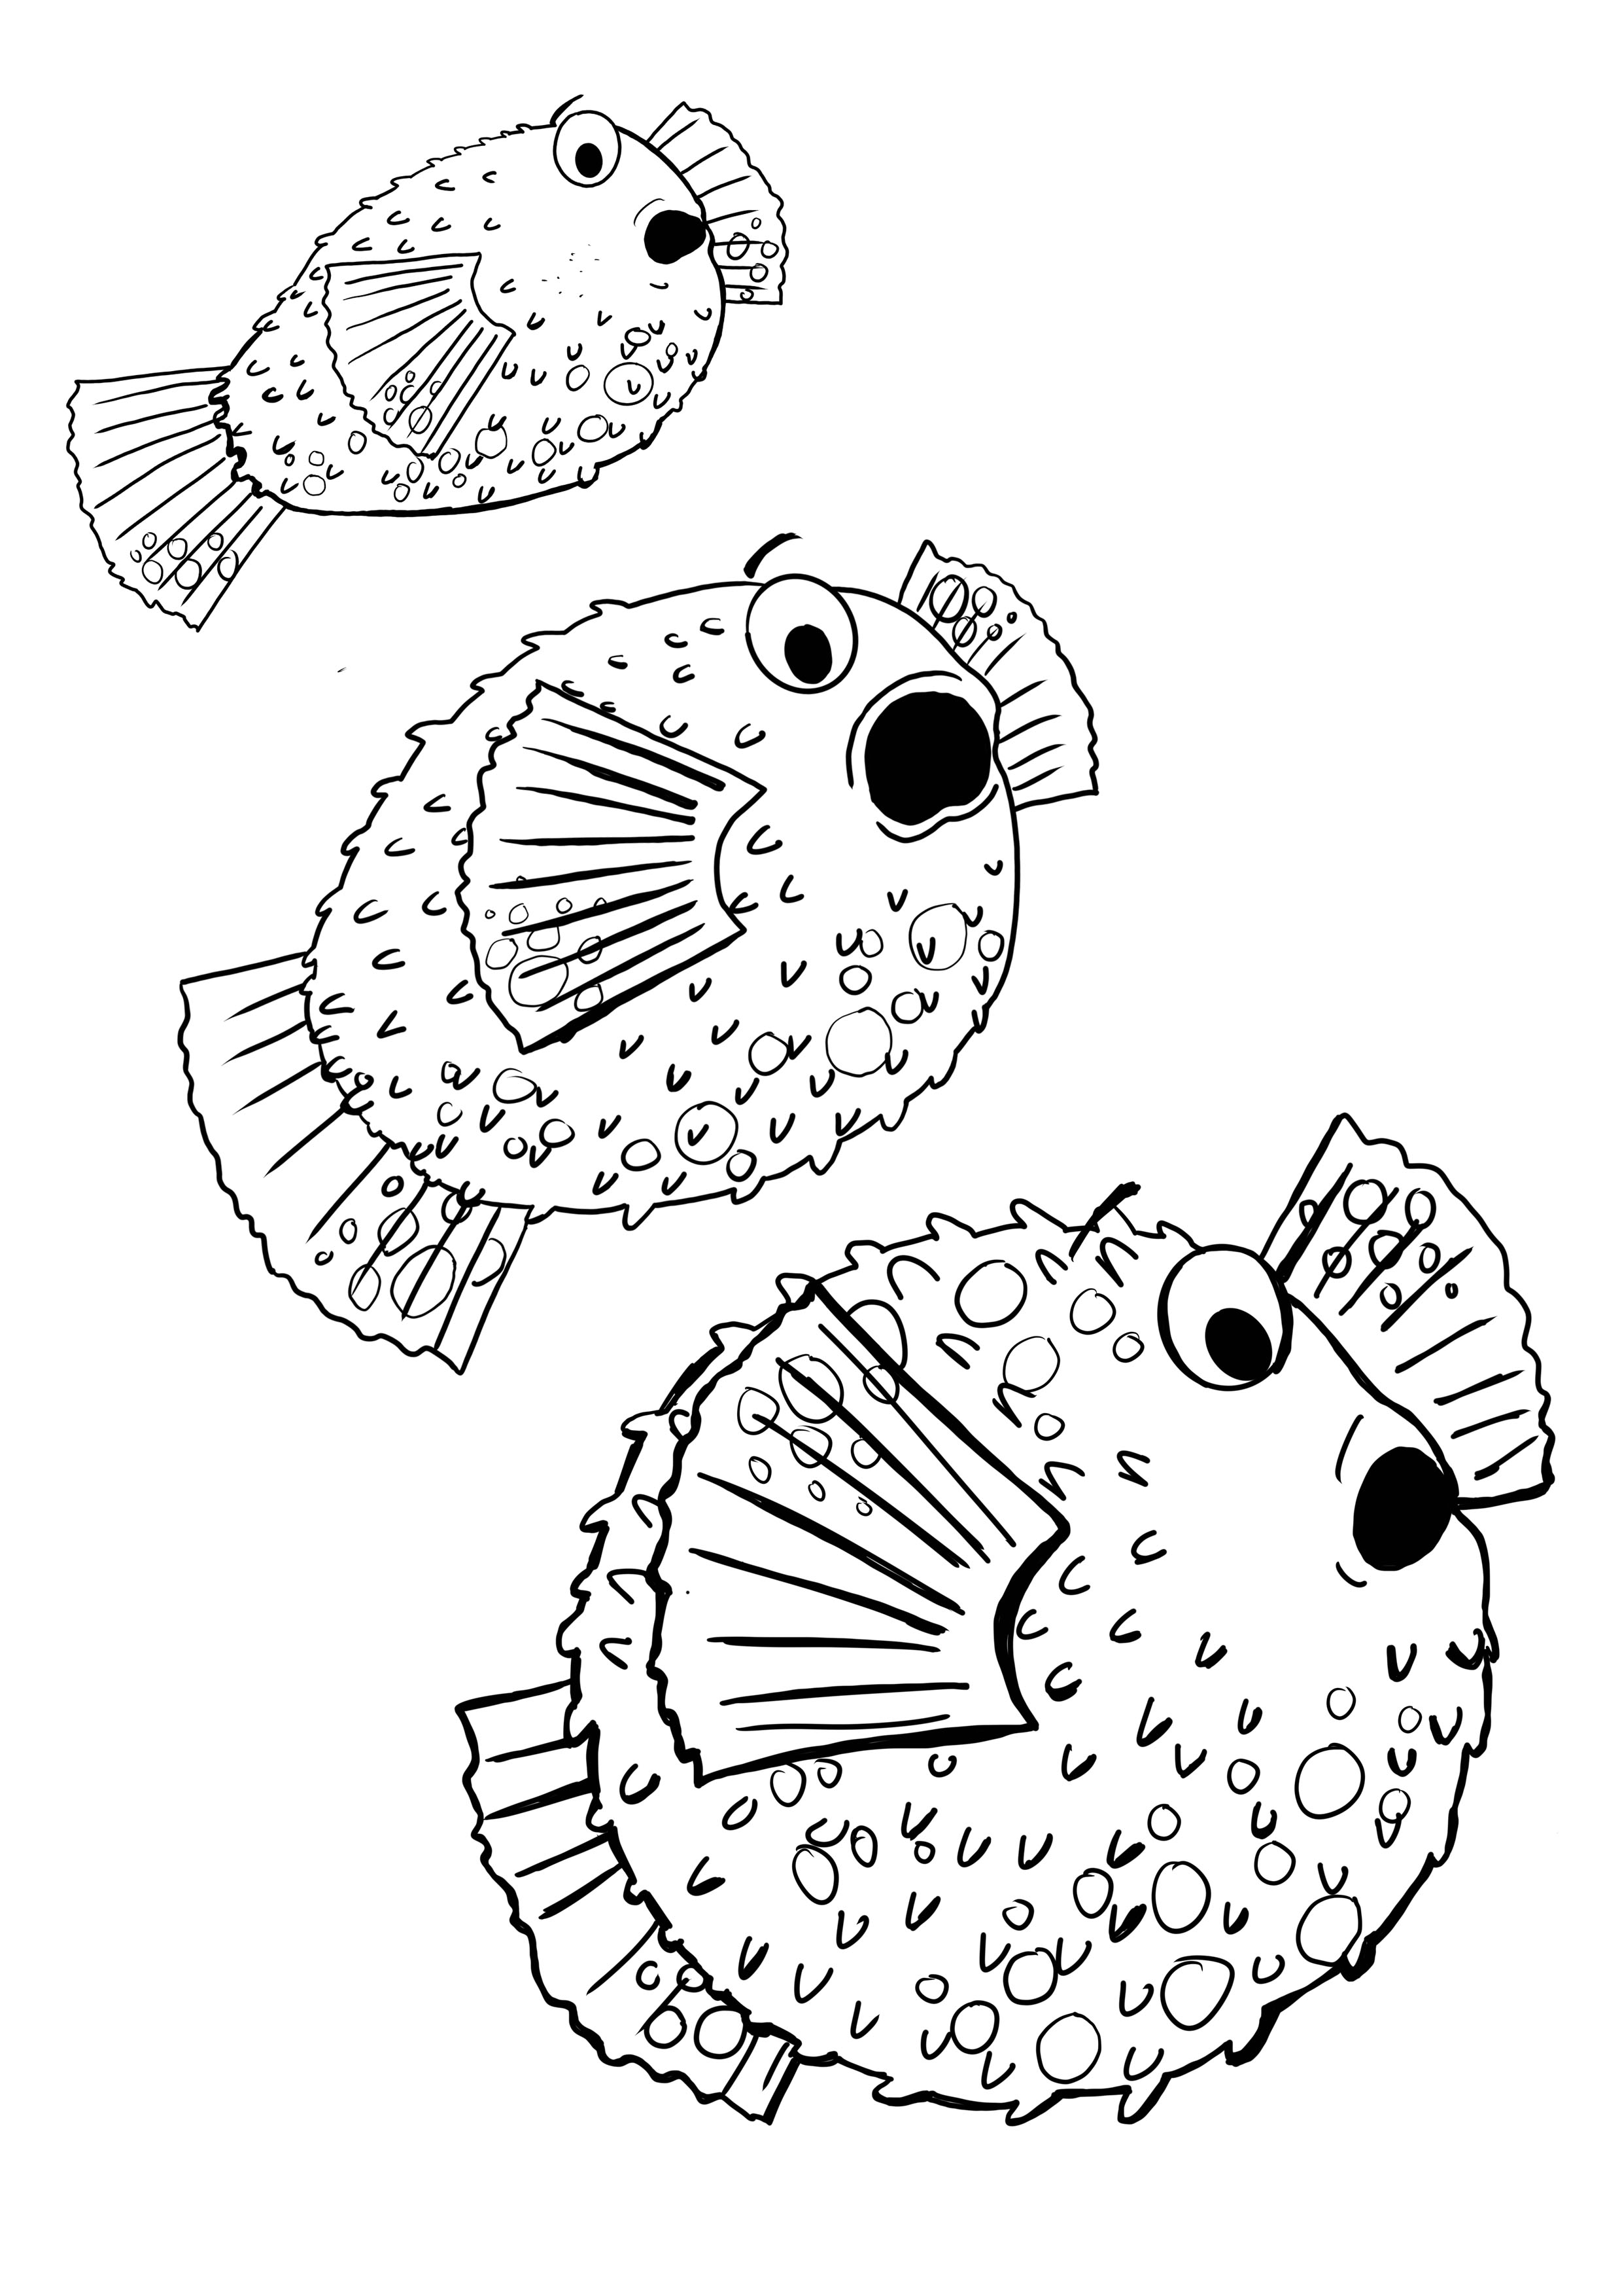

Piff in the Puffle © 2022 Sarah Lavelle